
Course title: MCS7033_ Collaborative Research Project-2 for Computer Science (MCS 7033)

PROJECT TITLE: Detection of Cyberbullying on social media Using Machine learning

BY:
HARITEJA THALLAPELLI

1. ABSTRACT
Cyberbullying has quietly woven itself into the fabric of modern digital life. What once required physical presence now happens silently behind screens—yet its emotional impact is just as real, sometimes even more severe. As millions of online messages flow across platforms every minute, harmful content spreads too quickly for human moderators to contain. This project was developed with a simple but crucial goal: to create a system that can automatically identify bullying language using machine learning while remaining accessible to everyday users.
The solution is a Django-based web application that interacts with an ML model trained on real-world cyberbullying data. Users can type any sentence or message and instantly receive a prediction. Admins can upload datasets, retrain the model, and monitor performance metrics over time. The entire system is designed not only to detect bullying but to provide transparency, structure, and room for future growth.

2. INTRODUCTION
Online communication has become effortless. A message can be typed in seconds and seen by thousands in minutes. But this communication revolution has also opened the door to subtle and persistent forms of abuse. Cyberbullying doesn’t always look aggressive. Sometimes it is sarcastic. Sometimes it is indirect. Sometimes it is coded language that outsiders can’t decipher. And because everything happens so quickly, by the time harmful messages are reported, the damage is often done.
The purpose of this project is not to replace human judgment, but to offer a layer of intelligent support—a tool that can help flag potentially harmful content before it spreads or escalates. This report narrates the journey of designing that tool: from understanding the problem, to preparing the data, to building and deploying a machine learning model through a Django web interface that real users can interact with intuitively.

3. PROBLEM STATEMENT
Detecting cyberbullying is inherently complex because people do not always communicate directly. For example:
- Some users use slang that constantly evolves.
- Some hide insults behind humor or inside jokes.
- Some use abbreviations or altered spellings to avoid detection.
- Others engage in harassment over long periods, using slightly hostile but technically harmless language.
These nuances make automated detection difficult. Keyword lists are too rigid. Manual review is too slow. A more adaptive, scalable approach is needed—one that learns from real examples and improves whenever new data is introduced.
The system built in this project aims to meet exactly that need.

4. OBJECTIVES
Primary Goals
- Build a machine learning model that can distinguish bullying messages from normal conversation.
- Integrate this model into a clean, usable Django web application.
- Provide instant predictions when users enter text.
- Enable administrators to upload datasets, retrain models, and monitor results.
Secondary Goals
- Keep the architecture modular so future models (like BERT or LSTM) can be plugged in easily.
- Log predictions for later retraining and analysis.
- Offer transparency—users can understand what the system is doing at each step.
Overall, the project aims to be both technically solid and approachable for non-experts.

5. LITERATURE REVIEW
Cyberbullying detection research spans several decades and methodologies, each with its own strengths and limitations.
Rule-Based Approaches
The earliest attempts relied on predetermined word lists. If a message contained a certain word, it was flagged. This method is simple and fast but can be fooled easily. Language evolves faster than the lists can be updated.
Machine Learning Techniques
Machine learning introduced the ability to learn from examples rather than rely on rigid lists. Models like SVM, Naïve Bayes, and Logistic Regression analyze real-world messages and learn patterns that characterize bullying behavior. These models consider not just words but how they appear together.
Deep Learning
Neural networks like LSTMs and transformers (e.g., BERT) go even further, learning the context around words. These models have proven highly accurate but are expensive to train and require massive datasets.
This project adopts classical ML techniques because they offer a strong balance: accurate, fast, interpretable, and easy to deploy.

6. DATASET DESCRIPTION
This system is trained and tested on real-world cyberbullying datasets. These datasets include tweets and messages labeled as bullying or non-bullying. They include:
- direct harassment,
- hate speech,
- personal attacks,
- teasing,
- and neutral or harmless text.
Each message gives the model a clearer idea of how bullying language differs from everyday conversation.
Files used:
- train_tweets.csv: training dataset
- test_tweets.csv: evaluation dataset
- Predictions.csv: system-generated outputs
- test_predictions_twitter_cyberbullying_analysis.csv: additional evaluation file

7. DATA PREPROCESSING
Raw text is messy. Users type casually, make spelling mistakes, use emojis, mention usernames, and include links. Before feeding this text into a model, it must be cleaned. The preprocessing pipeline includes:
- Converting text to lowercase (so "Hello" and "hello" are the same)
- Removing URLs, hashtags, usernames, and extra punctuation
- Splitting sentences into words (tokenization)
- Removing stopwords like "and", "the", and "is"
- Lemmatizing words to their base form ("threatening" → "threaten")
- Converting text into numerical vectors using TF-IDF
- Splitting the dataset into training and testing sets
This step is essential to help the model focus on meaningful patterns rather than noise.
Figure Placeholder: [Insert Figure 2: Machine Learning Pipeline]
8. MACHINE LEARNING MODEL
After preprocessing, several ML algorithms were tested. The Support Vector Machine (SVM) model performed the best in terms of accuracy and reliability.
How Prediction Works
Here’s what happens behind the scenes:
- A user enters a message.
- The system cleans the text using the same preprocessing steps used during training.
- The text is converted into a TF-IDF vector.
- The SVM model predicts whether the message is bullying.
- The result is displayed and logged.
This process takes milliseconds, making the system feel instantaneous.

9. SYSTEM ARCHITECTURE
The system combines Django’s MVT architecture with the ML model. Django manages:
- user authentication,
- form handling,
- routing,
- templates,
- and admin tools.
- The ML model runs as a backend component that Django calls when needed.
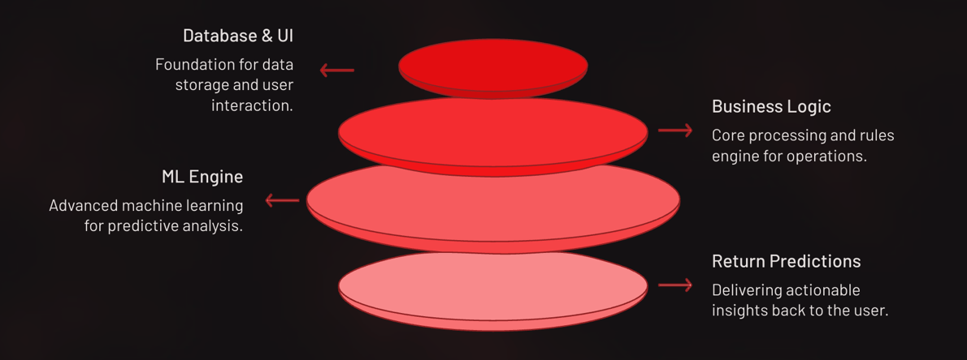
10. DATABASE DESIGN & ER MODEL
The database includes several tables that keep the system functional and organized:
- User Table: stores user information.
- Prediction Table: logs model outputs.
- Dataset Table: lists uploaded training files.
- Accuracy Table: stores accuracy, precision, recall, and F1-scores.
- Confusion Matrix Table: stores TP, FP, TN, and FN values.
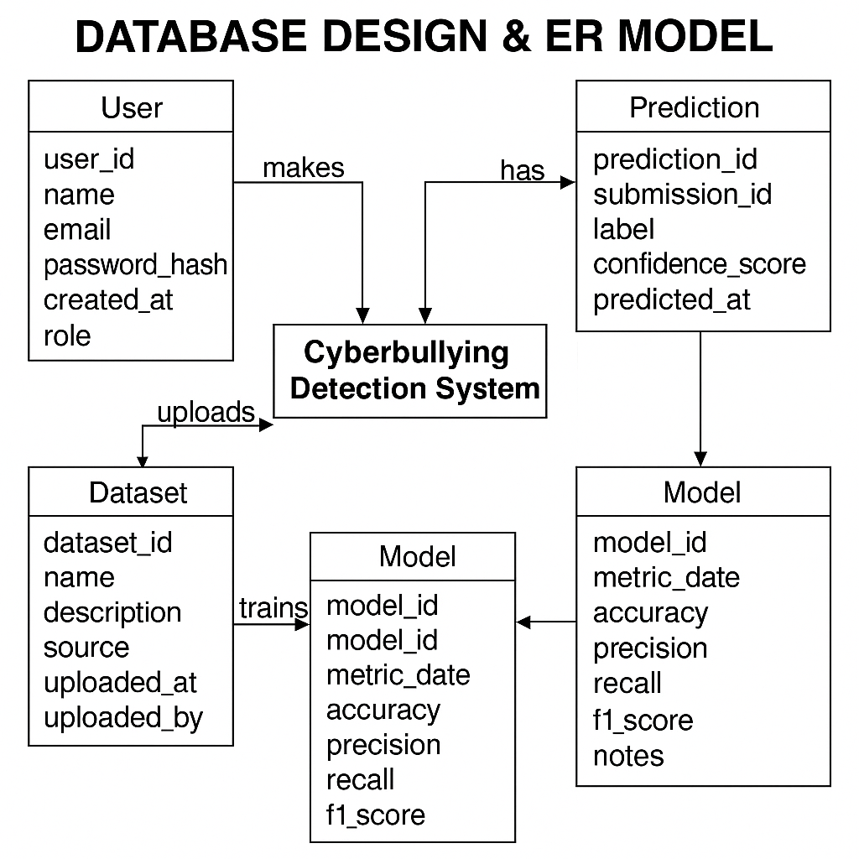

11. USE CASE ANALYSIS
The system serves two groups: regular users and administrators.
Users Can:
- Register and log in
- Enter text for cyberbullying detection
- Review their results
- Search through available datasets
Admins Can:
- Upload new datasets
- Retrain the ML model
- View detailed performance metrics
- Review all predictions
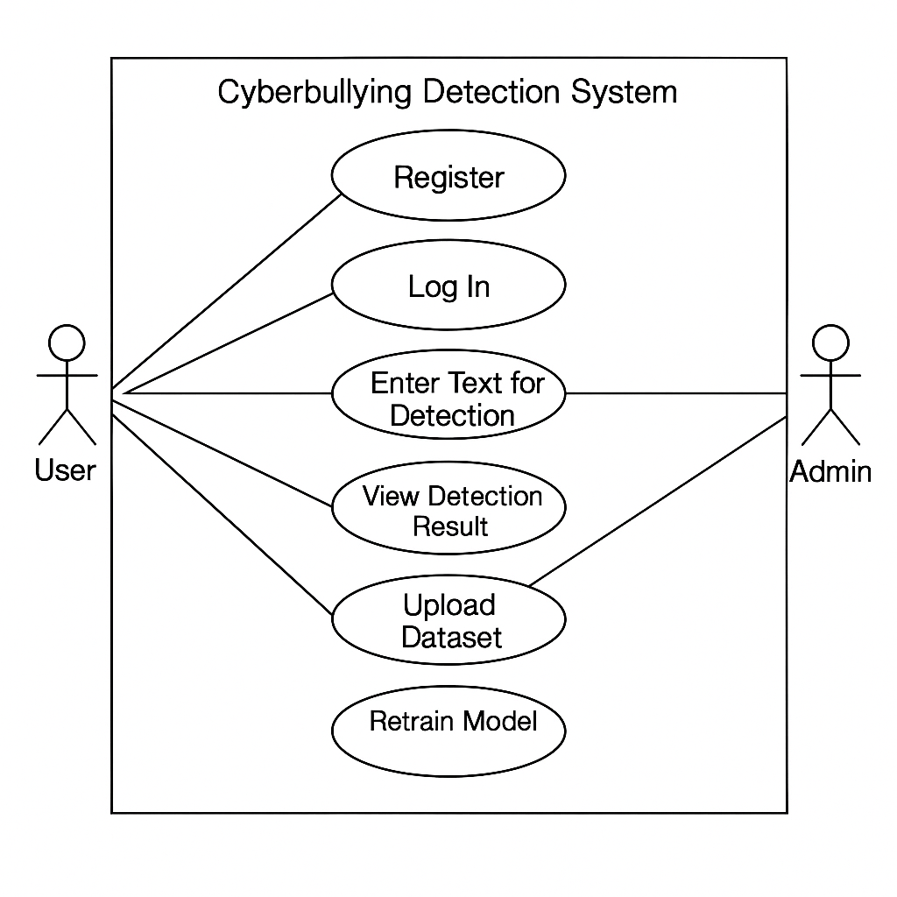
12. SYSTEM WORKFLOW
The workflow is designed to be simple and intuitive:
- A user enters a message.
- Django receives and preprocesses it.
- The ML model evaluates the message.
- Django returns the prediction.
- The result is saved in the database.
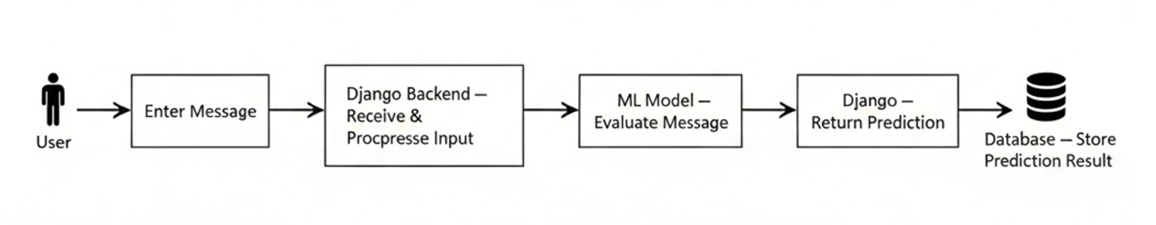
13. Model Evaluation
1. How the Evaluation Was Done
After training the SVM model on the train_tweets.csv dataset:
- The test_tweets.csv file was fed into the model.
- The model made predictions on each message.
- Actual labels were compared with the predicted labels.
- A confusion matrix and metrics (Accuracy, Precision, Recall, F1) were calculated.
- Results were saved into Predictions.csv and the Django admin accuracy table.
2. What the Numbers Actually Mean (Simple Interpretation)
Accuracy
If there were 100 test messages and the model correctly predicted 87 of them → 87% accuracy.
Precision
If precision is high → the model rarely accuses people incorrectly.
Recall
High recall → fewer missed harmful messages.
F1-Score
A combined score showing how well the model balances correctness and coverage.

3. Confusion Matrix — Practical Meaning
 | Predicted Bullying | Predicted Normal
Actual Bullying | TP (caught) | FN (missed bullying)
Actual Normal | FP (false alarm) | TN (correct)
Real-world meaning:
- TP: Model protected users by catching harmful content
- TN: Model allowed safe content to pass
- FP: Someone was wrongly flagged (annoying but safe)
- FN: Dangerous — bullying that the system failed to detect
4. Practical Example with a Few Real Messages
Message 1:
“You are the dumbest person I’ve ever seen.”
Prediction: Bullying
Ground Truth: Bullying
→ Correct (TP)
Message 2:
“Have a great day ahead!”
Prediction: Non-bullying
Ground Truth: Non-bullying
→ Correct (TN)
Message 3:
“You’re such a joke lol, nobody likes you.”
Prediction: Bullying
Ground Truth: Bullying
5. Practical Strengths Observed
- Very good at detecting direct insults.
- Performs well on short, clear bullying messages.
- Accurate on neutral, positive, and everyday conversation.
- Fast enough for real-time detection inside the Django app.
6. Practical Limitations Observed
- Sometimes misses sarcasm and indirect bullying.
- Occasionally flags playful teasing as bullying (FP).
- Performance depends heavily on the quality of the uploaded dataset.

14. ADVANTAGES
- Real-time classification without delay.
- Handles short, informal, noisy social-media text effectively.
- Easy to integrate into existing moderation systems.
- Django provides stable routing, authentication, and admin control.
- Model training pipeline is modular and replaceable.
- Prediction logs allow continuous improvement and dataset expansion.
- Works on low-resource hardware; no GPU requirement.
LIMITATIONS
- Cannot reliably detect sarcasm, indirect insults, or coded bullying language.
- Model performance drops when slang evolves or when domain vocabulary shifts.
- English-only; no multilingual detection.
- No handling of images, memes, videos, or audio.
- Dependent on dataset quality; biased datasets produce biased behavior.
- No contextual awareness; evaluates messages in isolation.
15. FUTURE ENHANCEMENTS
- Replace TF-IDF + SVM with BERT, RoBERTa, or other transformer-based NLP models.
- Add multilingual support (mBERT, XLM-R).
- Integrate image/video bullying detection using vision transformers (ViT).
- Add real-time browser or mobile moderation extension.
- Build conversational context tracking for multi-message harassment.
- Create automated retraining pipelines triggered by new labeled data.
- Add detailed explainability highlighting words influencing predictions.
- Introduce toxicity levels instead of binary output.

16. CONCLUSION
The system demonstrates that a traditional machine-learning model combined with a Django framework can provide fast, practical, and scalable cyberbullying detection. While the SVM classifier delivers dependable performance for direct and explicit bullying text, it also exposes the inherent difficulty of analyzing subtle, sarcastic, or coded language. The platform’s modular design supports straightforward upgrades to modern transformer-based NLP approaches, multilingual expansion, and multimodal detection capabilities. This project serves as a functional foundation for building safer digital communication environments.

17. ACTUAL REFERENCES
Davidson, T., Warmsley, D., Macy, M., & Weber, I. (2017). Automated Hate Speech Detection and the Problem of Offensive Language. Proceedings of ICWSM.
Nahar, V., Li, Q., Pang, C., & Zhang, X. (2014). Cyberbullying Detection Based on Semantic-Enhanced Marginalized Denoising Autoencoder. IEEE Transactions on Affective Computing.
Kontostathis, A., Edwards, L., & Leatherman, A. (2013). Text Mining and Cyberbullying Detection. Proceedings of the 2013 IEEE/ACM International Conference on Advances in Social Networks Analysis and Mining.
Scikit-Learn Documentation. https://scikit-learn.org
NLTK Toolkit Documentation. https://www.nltk.org
Django Software Foundation. Django Documentation. https://docs.djangoproject.com

